Tạo 1 controller trong mục Controller: AccessController

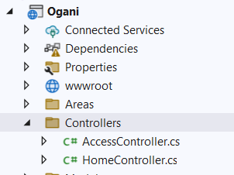

Them: using Ogani.Models;

QlbanVaLiContext csdl = new QlbanVaLiContext();

[HttpGet]

public IActionResult Login()

{

if(HttpContext.Session.GetString("UserName") == null)

{

return View();

}

else

{

return RedirectToAction("Index", "Home");

}

}

[HttpPost]

public IActionResult Login(TUser user)

{

if (HttpContext.Session.GetString("UserName") == null)

{

var u = csdl.TUsers.Where(x => x.Username.Equals(user.Username) &&

x.Password.Equals(user.Password)).FirstOrDefault();

if(u != null)

{

HttpContext.Session.SetString("UserName", u.Username.ToString());

return RedirectToAction("Index", "Home");

}

}

return View();

}

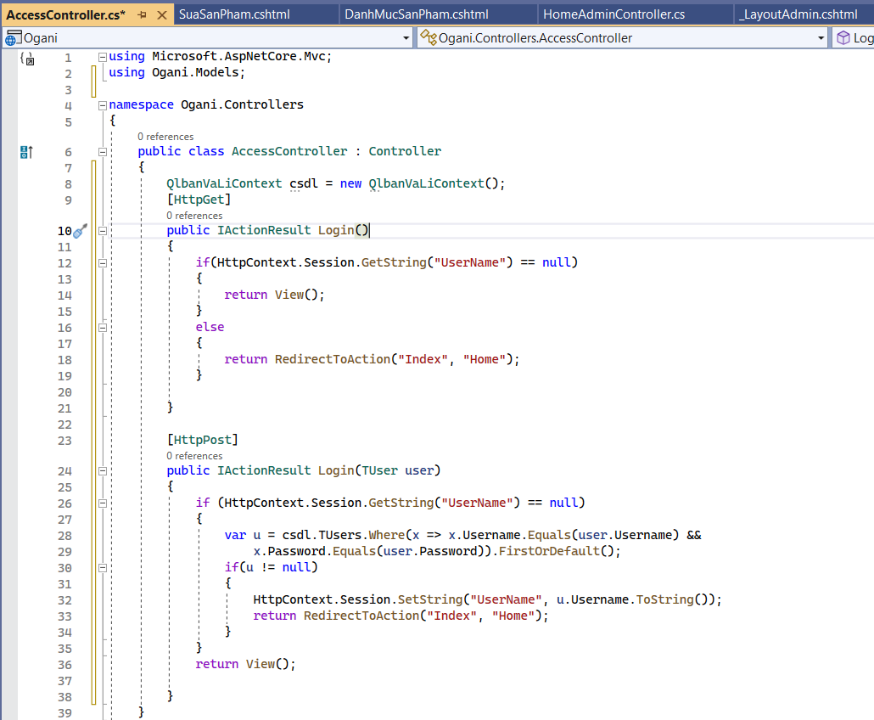

Add View cho Login ben tren: -> Razor View -> ko chon gi ca

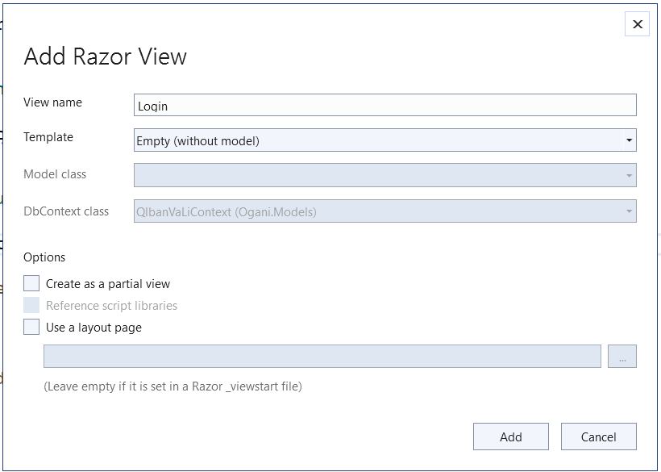

Copy nguon HTML tu trang Login cua Template: sang file Login moi

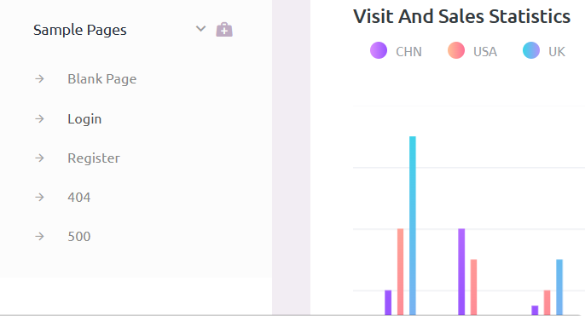

Thay the: assets/ -> LayoutAdmin/assets/

Vao Program.cs:

Them:

builder.Services.AddSession();

app.UseSession();

Sua lai: pattern: "{controller=Access}/{action=Login}/{id?}");

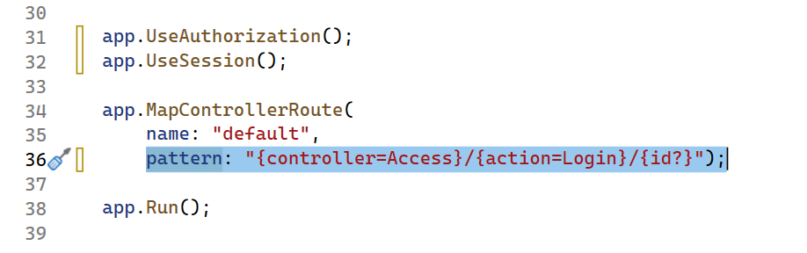

Copy ca doan code mau cua co vao file Login.cshtml:

@{

Layout = null;

}

@model TUser

<!DOCTYPE html>

<html lang="en">

<head>

<!-- Required meta tags -->

<meta charset="utf-8">

<meta name="viewport" content="width=device-width, initial-scale=1, shrink-to-fit=no">

<title>Purple Admin</title>

<!-- plugins:css -->

<link rel="stylesheet" href="../../LayoutAdmin/assets/vendors/mdi/css/materialdesignicons.min.css">

<link rel="stylesheet" href="../../LayoutAdmin/assets/vendors/css/vendor.bundle.base.css">

<!-- endinject -->

<!-- Plugin css for this page -->

<!-- End plugin css for this page -->

<!-- inject:css -->

<!-- endinject -->

<!-- Layout styles -->

<link rel="stylesheet" href="../../LayoutAdmin/assets/css/style.css">

<!-- End layout styles -->

<link rel="shortcut icon" href="../../LayoutAdmin/assets/images/favicon.ico" />

</head>

<body>

<div class="container-scroller">

<div class="container-fluid page-body-wrapper full-page-wrapper">

<div class="content-wrapper d-flex align-items-center auth">

<div class="row flex-grow">

<div class="col-lg-4 mx-auto">

<div class="auth-form-light text-left p-5">

<div class="brand-logo">

<img src="../../LayoutAdmin/assets/images/logo.svg">

</div>

<h4>Hello! let's get started</h4>

<h6 class="font-weight-light">Sign in to continue.</h6>

@* <form class="pt-3">*@

@using(Html.BeginForm("Login", "Access", FormMethod.Post)){

<div class="form-group">

@Html.TextBoxFor(x=>x.Username, new{@class="form-control form-control-lg",placeholder="Username", required="required", autofocus="autofocus"})

@*<input type="email" class="form-control form-control-lg" id="exampleInputEmail1" placeholder="Username">*@

</div>

<div class="form-group">

@Html.TextBoxFor(x=>x.Password, new{@class="form-control form-control-lg",placeholder="Password",type="Password" })

@* <input type="password" class="form-control form-control-lg" id="exampleInputPassword1" placeholder="Password">*@

</div>

<div class="mt-3">

<button class="btn btn-block btn-gradient-primary btn-lg font-weight-medium auth-form-btn" type="submit">SIGN IN</button>

@*<a class="btn btn-block btn-gradient-primary btn-lg font-weight-medium auth-form-btn" href="../../index.html">SIGN IN</a>*@

</div>

<div class="my-2 d-flex justify-content-between align-items-center">

<div class="form-check">

<label class="form-check-label text-muted">

<input type="checkbox" class="form-check-input"> Keep me signed in

</label>

</div>

<a href="#" class="auth-link text-black">Forgot password?</a>

</div>

<div class="mb-2">

<button type="button" class="btn btn-block btn-facebook auth-form-btn">

<i class="mdi mdi-facebook me-2"></i>Connect using facebook

</button>

</div>

<div class="text-center mt-4 font-weight-light">

Don't have an account? <a href="register.html" class="text-primary">Create</a>

</div>

}@*</form>*@

</div>

</div>

</div>

</div>

<!-- content-wrapper ends -->

</div>

<!-- page-body-wrapper ends -->

</div>

<!-- container-scroller -->

<!-- plugins:js -->

<script src="../../LayoutAdmin/assets/vendors/js/vendor.bundle.base.js"></script>

<!-- endinject -->

<!-- Plugin js for this page -->

<!-- End plugin js for this page -->

<!-- inject:js -->

<script src="../../LayoutAdmin/assets/js/off-canvas.js"></script>

<script src="../../LayoutAdmin/assets/js/hoverable-collapse.js"></script>

<script src="../../LayoutAdmin/assets/js/misc.js"></script>

<!-- endinject -->

</body>

</html>

Nhung neu truy cap theo link van vao duoc trang chu vay nen:

Tao them 1 folder trong Model -> class

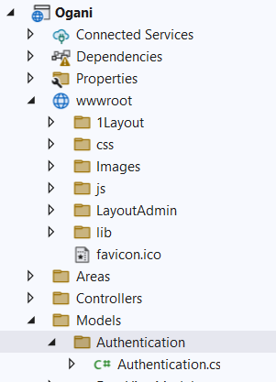

using Microsoft.AspNetCore.Mvc;

using Microsoft.AspNetCore.Mvc.Filters;

namespace Test.Models.Authentication

{

public class Authentication : ActionFilterAttribute

{

public override void OnActionExecuting(ActionExecutingContext context)

{

context.Result = new RedirectToRouteResult(

new RouteValueDictionary

{

{"Controller", "Access" },

{"Action", "Login" }

});

}

}

}

Sang HomeController them Authentication

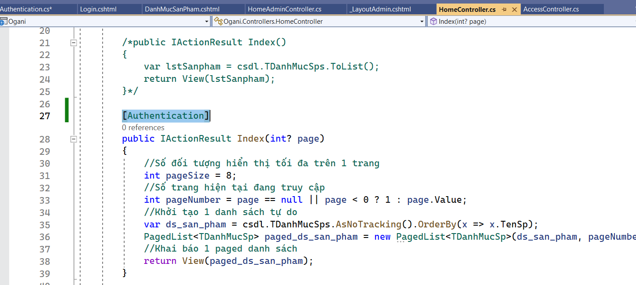

**Logout:**

public IActionResult Logout()

{

HttpContext.Session.Clear();

HttpContext.Session.Remove("UserName");

return RedirectToAction("Login", "Access");

}

Vao file LayoutOgani:

Tim kiem Login -> Logout

<**a** **asp-controller**="Access" **asp-action**="Logout"><i class="fa fa-user"></i> Logout</**a**>

